Name: Patel Virashree
Project #4: VGA
Scope of the Project: The purpose of this project is to being able to display text using VGA on the monitor by using ROM.
Modules: ROM (Memory_bb) , vga driver that provides timing and Shift register.
Results:
Compilation Report :
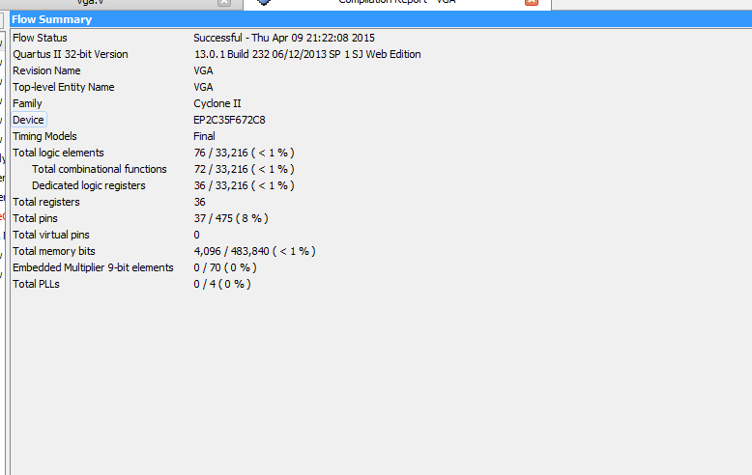

Time Quest analysis :
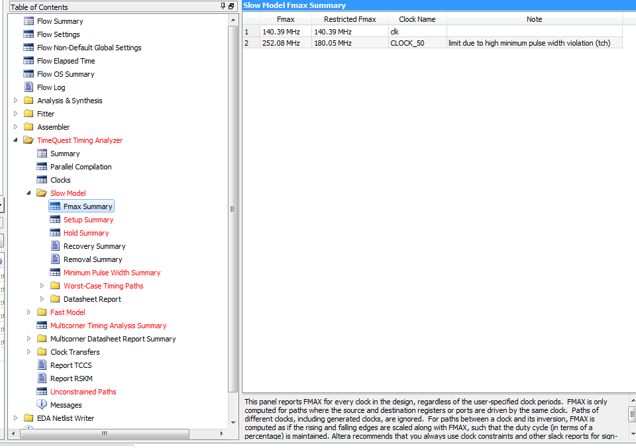

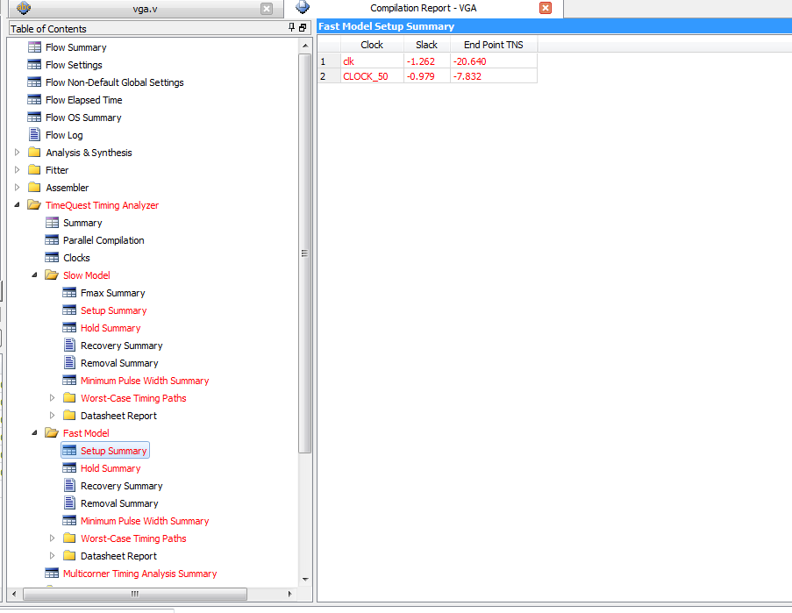

Waveforms: Here are the waveforms in ModelSim , it shows how shift register works and spits out bit by bit value on to the screen. We can see how the bits are printed on the screen line by line

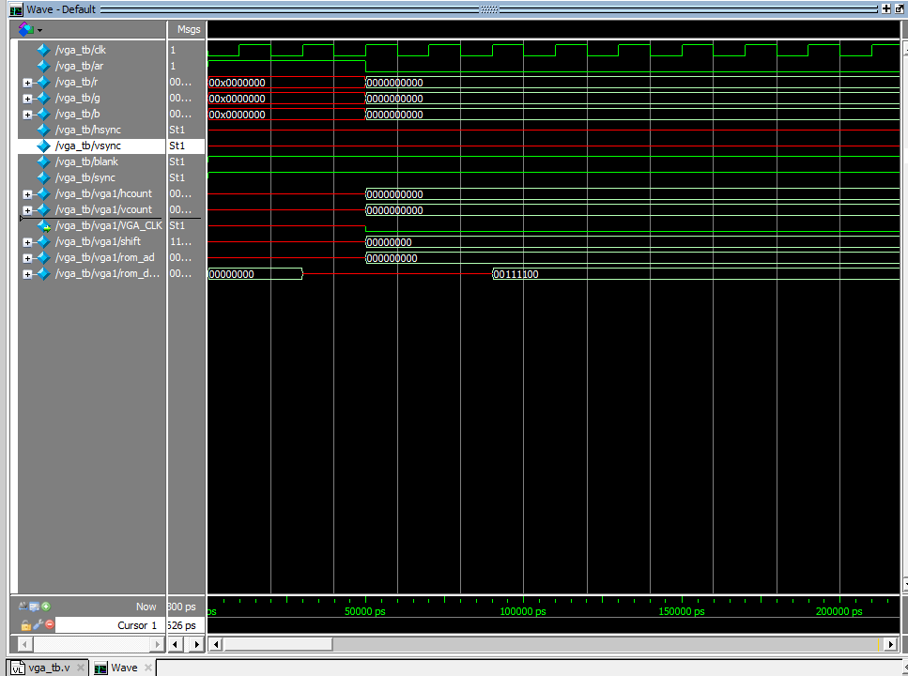
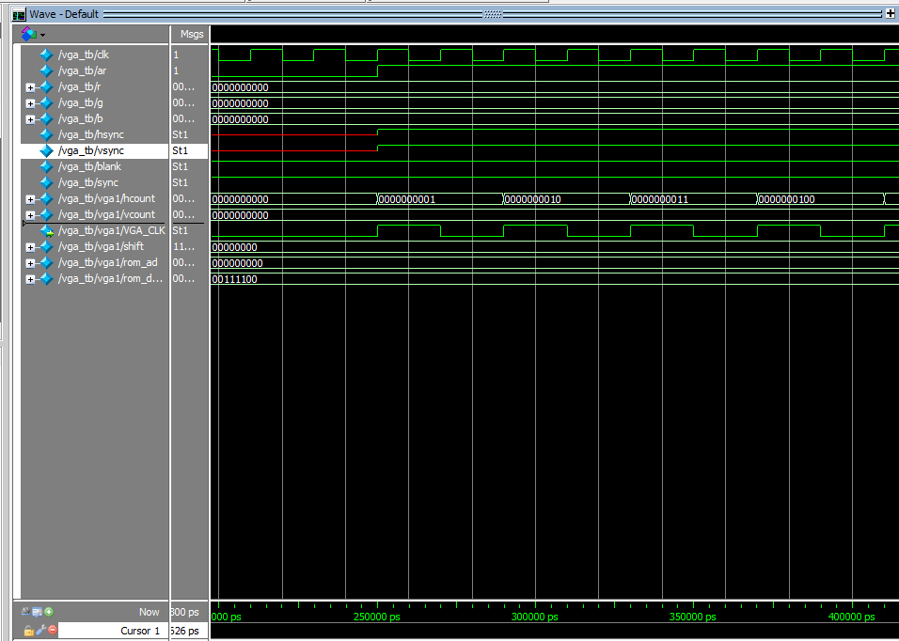

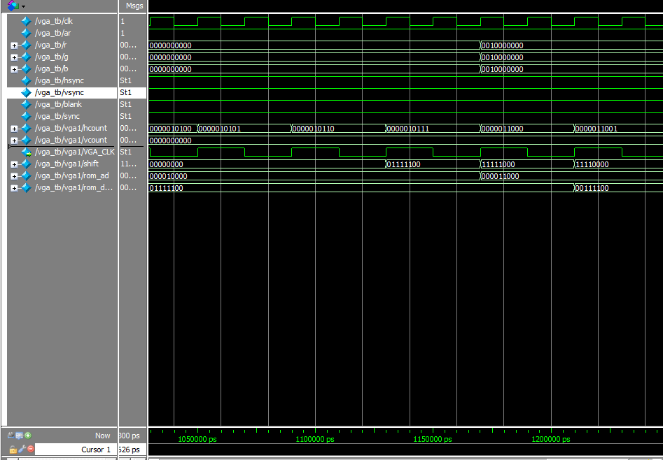
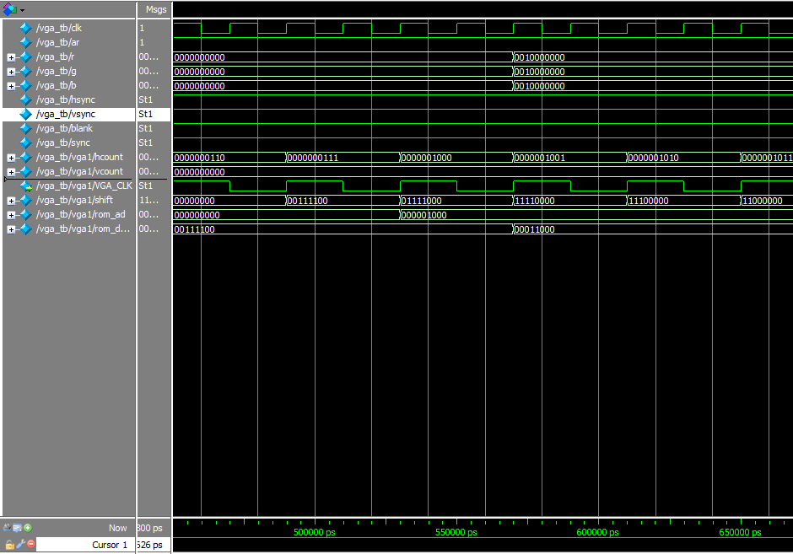

Output on the Monitor: The monitor prints all the values that are in the Memory_bb file i.e. ROM in different columns and then repeats the same in rows.
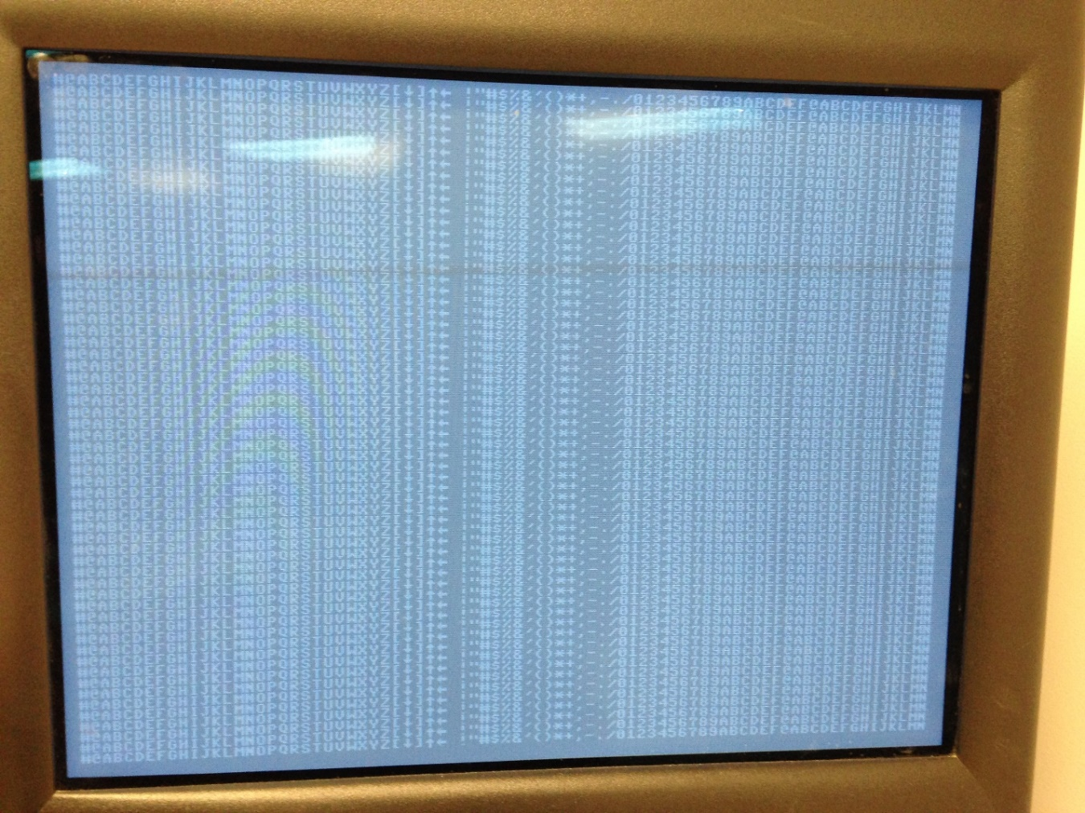
What did you learn: Of course learned how VGA works but also learned not to give up :D

Code :
// VGA driver design
// File vga.v
// Generates VGA timing and data signals to drive a VGA monitor
// in 640 x 480 mode
// Patel Virashree
// April 9 , 2015

module VGA(CLOCK_50, ar, VGA_R, VGA_G, VGA_B, VGA_HS, VGA_VS, VGA_BLANK, VGA_SYNC, VGA_CLK);
input CLOCK_50; // 50 MHz input clock
input ar; // Active low asynchronous reset
output [9:0] VGA_R, VGA_G, VGA_B; // Red, green, and blue outputs
output VGA_HS; // Output horizontal synch
output VGA_VS; // Output vertical synch
output VGA_BLANK, VGA_SYNC;
output VGA_CLK;
reg r, g, b;
reg hsync, vsync;
reg clk; // 25 MHz clock

reg [9:0] hcount, vcount; // Counters used for creating the vsync and hsync signals

reg video_on_h, video_on_v;

assign VGA_BLANK = 1'b1;//hsync & vsync;
assign VGA_SYNC = 1'b1;
assign VGA_HS = hsync;
assign VGA_VS = vsync;

assign VGA_R = {1'b0, r, 7'b0};
assign VGA_G = {1'b0, g, 7'b0};
assign VGA_B = {1'b0, b, 7'b0};

parameter [9:0] h_max = 10'd799;
parameter [9:0] v_max = 10'd524;

reg [7:0]shift;

reg count ;
reg load ;

wire [8:0] rom_ad;
wire [7:0] rom_data;

Memory_bb rom (.address(rom_ad) , .clock(CLOCK_50) , .q(rom_data));

assign rom_ad = {hcount[8:3] , vcount[2] , vcount[1] , vcount[0]};
assign y = shift[7];

always @(negedge ar or posedge CLOCK_50)
if(~ar)
clk = 1'b0;
else
clk = ~clk;
assign VGA_CLK = clk;
// Generate the hcount & hsync

//initial
// begin
// load = 0;
// count = 0;
//end

always @(negedge ar or posedge clk)
if(~ar)
begin
hcount = 10'b0;
video_on_h = 1'b0;
end

else
begin
if(hcount >= h_max)
hcount = 10'b0;
else
hcount = hcount + 1;

if(hcount <= 755 && hcount >= 659)
hsync = 1'b0;
else
hsync = 1'b1;

if(hcount <= 639)
video_on_h = 1'b1;
else
video_on_h = 1'b0;

end // else: !if(~ar)

always @(negedge ar or posedge clk)
if(~ar)
begin
vcount = 10'b0;
video_on_v = 1'b0;
end

else
begin
if(vcount >= v_max)
vcount = 10'b0;
else
if(hcount == 10'd699)
vcount = vcount + 1;

if(vcount <= 494 && vcount >= 493)
vsync = 1'b0;
else
vsync = 1'b1;

if(vcount <= 479)
video_on_v = 1'b1;
else
video_on_v = 1'b0;

end // else: !if(~ar)

always @ (posedge clk or negedge ar)

begin
if(~ar) begin
shift = 8'b00000000;
//count = 0;
end

else if(hcount[2:0] == 3'b111)
begin
shift = rom_data;
end

else
shift = shift<<1;//{shift[7:1] , 1'b0};
end

// Generate R,G,B outputs for a colorbar pattern (just use the hcount position)

always @(negedge ar or posedge clk)
if(~ar)
begin

r = 1'b0;
g = 1'b0;
b = 1'b0;
end
else
begin
if(video_on_h && video_on_v) // Allow non-zero RGB only within the 640x480 area
begin
r = shift[7];
g = r;
b = g;
//r = hcount[8];
//g = hcount[7];
//b = hcount[6];
end
else
begin
r = 1'b0;
g = 1'b0;
b = 1'b0;
end // else: !if(video_on_v & video_on_h)

end // else: !if(~ar)

endmodule // vga

Memory_bb.v
// megafunction wizard: %ROM: 1-PORT%
// GENERATION: STANDARD
// VERSION: WM1.0
// MODULE: altsyncram

// ============================================================
// File Name: Memory_bb.v
// Megafunction Name(s):
// altsyncram
//
// Simulation Library Files(s):
// altera_mf
// ============================================================
// ************************************************************
// THIS IS A WIZARD-GENERATED FILE. DO NOT EDIT THIS FILE!
//
// 13.0.1 Build 232 06/12/2013 SP 1 SJ Web Edition
// ************************************************************

//Copyright (C) 1991-2013 Altera Corporation
//Your use of Altera Corporation's design tools, logic functions
//and other software and tools, and its AMPP partner logic
//functions, and any output files from any of the foregoing
//(including device programming or simulation files), and any
//associated documentation or information are expressly subject
//to the terms and conditions of the Altera Program License
//Subscription Agreement, Altera MegaCore Function License
//Agreement, or other applicable license agreement, including,
//without limitation, that your use is for the sole purpose of
//programming logic devices manufactured by Altera and sold by
//Altera or its authorized distributors. Please refer to the
//applicable agreement for further details.

// synopsys translate_off
`timescale 1 ps / 1 ps
// synopsys translate_on
module Memory_bb (
address,
clock,
q);

input [8:0] address;
input clock;
output [7:0] q;
`ifndef ALTERA_RESERVED_QIS
// synopsys translate_off
`endif
tri1 clock;
`ifndef ALTERA_RESERVED_QIS
// synopsys translate_on
`endif

wire [7:0] sub_wire0;
wire [7:0] q = sub_wire0[7:0];

altsyncram altsyncram_component (
.address_a (address),
.clock0 (clock),
.q_a (sub_wire0),
.aclr0 (1'b0),
.aclr1 (1'b0),
.address_b (1'b1),
.addressstall_a (1'b0),
.addressstall_b (1'b0),
.byteena_a (1'b1),
.byteena_b (1'b1),
.clock1 (1'b1),
.clocken0 (1'b1),
.clocken1 (1'b1),
.clocken2 (1'b1),
.clocken3 (1'b1),
.data_a ({8{1'b1}}),
.data_b (1'b1),
.eccstatus (),
.q_b (),
.rden_a (1'b1),
.rden_b (1'b1),
.wren_a (1'b0),
.wren_b (1'b0));
defparam
altsyncram_component.clock_enable_input_a = "BYPASS",
altsyncram_component.clock_enable_output_a = "BYPASS",
altsyncram_component.init_file = "tcgrom.mif",
altsyncram_component.intended_device_family = "Cyclone II",
altsyncram_component.lpm_hint = "ENABLE_RUNTIME_MOD=NO",
altsyncram_component.lpm_type = "altsyncram",
altsyncram_component.numwords_a = 512,
altsyncram_component.operation_mode = "ROM",
altsyncram_component.outdata_aclr_a = "NONE",
altsyncram_component.outdata_reg_a = "CLOCK0",
altsyncram_component.widthad_a = 9,
altsyncram_component.width_a = 8,
altsyncram_component.width_byteena_a = 1;

endmodule

// ============================================================
// CNX file retrieval info
// ============================================================
// Retrieval info: PRIVATE: ADDRESSSTALL_A NUMERIC "0"
// Retrieval info: PRIVATE: AclrAddr NUMERIC "0"
// Retrieval info: PRIVATE: AclrByte NUMERIC "0"
// Retrieval info: PRIVATE: AclrOutput NUMERIC "0"
// Retrieval info: PRIVATE: BYTE_ENABLE NUMERIC "0"
// Retrieval info: PRIVATE: BYTE_SIZE NUMERIC "8"
// Retrieval info: PRIVATE: BlankMemory NUMERIC "0"
// Retrieval info: PRIVATE: CLOCK_ENABLE_INPUT_A NUMERIC "0"
// Retrieval info: PRIVATE: CLOCK_ENABLE_OUTPUT_A NUMERIC "0"
// Retrieval info: PRIVATE: Clken NUMERIC "0"
// Retrieval info: PRIVATE: IMPLEMENT_IN_LES NUMERIC "0"
// Retrieval info: PRIVATE: INIT_FILE_LAYOUT STRING "PORT_A"
// Retrieval info: PRIVATE: INIT_TO_SIM_X NUMERIC "0"
// Retrieval info: PRIVATE: INTENDED_DEVICE_FAMILY STRING "Cyclone II"
// Retrieval info: PRIVATE: JTAG_ENABLED NUMERIC "0"
// Retrieval info: PRIVATE: JTAG_ID STRING "NONE"
// Retrieval info: PRIVATE: MAXIMUM_DEPTH NUMERIC "0"
// Retrieval info: PRIVATE: MIFfilename STRING "tcgrom.mif"
// Retrieval info: PRIVATE: NUMWORDS_A NUMERIC "512"
// Retrieval info: PRIVATE: RAM_BLOCK_TYPE NUMERIC "0"
// Retrieval info: PRIVATE: RegAddr NUMERIC "1"
// Retrieval info: PRIVATE: RegOutput NUMERIC "1"
// Retrieval info: PRIVATE: SYNTH_WRAPPER_GEN_POSTFIX STRING "0"
// Retrieval info: PRIVATE: SingleClock NUMERIC "1"
// Retrieval info: PRIVATE: UseDQRAM NUMERIC "0"
// Retrieval info: PRIVATE: WidthAddr NUMERIC "9"
// Retrieval info: PRIVATE: WidthData NUMERIC "8"
// Retrieval info: PRIVATE: rden NUMERIC "0"
// Retrieval info: LIBRARY: altera_mf altera_mf.altera_mf_components.all
// Retrieval info: CONSTANT: CLOCK_ENABLE_INPUT_A STRING "BYPASS"
// Retrieval info: CONSTANT: CLOCK_ENABLE_OUTPUT_A STRING "BYPASS"
// Retrieval info: CONSTANT: INIT_FILE STRING "tcgrom.mif"
// Retrieval info: CONSTANT: INTENDED_DEVICE_FAMILY STRING "Cyclone II"
// Retrieval info: CONSTANT: LPM_HINT STRING "ENABLE_RUNTIME_MOD=NO"
// Retrieval info: CONSTANT: LPM_TYPE STRING "altsyncram"
// Retrieval info: CONSTANT: NUMWORDS_A NUMERIC "512"
// Retrieval info: CONSTANT: OPERATION_MODE STRING "ROM"
// Retrieval info: CONSTANT: OUTDATA_ACLR_A STRING "NONE"
// Retrieval info: CONSTANT: OUTDATA_REG_A STRING "CLOCK0"
// Retrieval info: CONSTANT: WIDTHAD_A NUMERIC "9"
// Retrieval info: CONSTANT: WIDTH_A NUMERIC "8"
// Retrieval info: CONSTANT: WIDTH_BYTEENA_A NUMERIC "1"
// Retrieval info: USED_PORT: address 0 0 9 0 INPUT NODEFVAL "address[8..0]"
// Retrieval info: USED_PORT: clock 0 0 0 0 INPUT VCC "clock"
// Retrieval info: USED_PORT: q 0 0 8 0 OUTPUT NODEFVAL "q[7..0]"
// Retrieval info: CONNECT: @address_a 0 0 9 0 address 0 0 9 0
// Retrieval info: CONNECT: @clock0 0 0 0 0 clock 0 0 0 0
// Retrieval info: CONNECT: q 0 0 8 0 @q_a 0 0 8 0
// Retrieval info: GEN_FILE: TYPE_NORMAL Memory.v TRUE
// Retrieval info: GEN_FILE: TYPE_NORMAL Memory.inc FALSE
// Retrieval info: GEN_FILE: TYPE_NORMAL Memory.cmp FALSE
// Retrieval info: GEN_FILE: TYPE_NORMAL Memory.bsf FALSE
// Retrieval info: GEN_FILE: TYPE_NORMAL Memory_inst.v FALSE
// Retrieval info: GEN_FILE: TYPE_NORMAL Memory_bb.v TRUE
// Retrieval info: GEN_FILE: TYPE_NORMAL Memory_bb.inc FALSE
// Retrieval info: GEN_FILE: TYPE_NORMAL Memory_bb.cmp FALSE
// Retrieval info: GEN_FILE: TYPE_NORMAL Memory_bb.bsf FALSE
// Retrieval info: GEN_FILE: TYPE_NORMAL Memory_bb_inst.v FALSE
// Retrieval info: GEN_FILE: TYPE_NORMAL Memory_bb_bb.v TRUE
// Retrieval info: LIB_FILE: altera_mf

vga_tb.v
// Testbench
// tb_vga.v
// Don M. Gruenbacher
// Feb. 10, 2000

`timescale 10 ns / 1 ns

module vga_tb;
reg clk;
reg ar;

wire [9:0] r, g, b;
wire hsync, vsync, blank, sync;

// instantiate the vga design
VGA vga1 (.CLOCK_50(clk), .ar(ar), .VGA_R(r), .VGA_G(g), .VGA_B(b), .VGA_HS(hsync), .VGA_VS(vsync), .VGA_BLANK(blank),
.VGA_SYNC(sync));
// vga(CLOCK_50, ar, VGA_R, VGA_G, VGA_B, VGA_HS, VGA_VS, VGA_BLANK, VGA_SYNC)

initial
begin
clk = 1'b0; // set to 0 so toggling can occur

ar = 1'b1; // Start reset at 1

#5 ar = 1'b0; // Set reset to 0 after 5 ns

#20 ar = 1'b1; // Set reset to 1
end

// Controls the test clock
always
#1 clk = ~clk; // For 20 ns period (50 MHz)
endmodule

